E COMMERCE MICROSERVICES

Tech Stack:
Angular
Used to build the frontend user interface of the application.
It sends HTTP requests to the backend and displays data to users.
API Gateway (Spring Cloud Gateway)
Acts as a single entry point for all client requests.
Routes requests to appropriate microservices and handles security centrally.
Spring Boot
Framework used to build individual microservices quickly and easily.
Provides embedded servers, REST APIs, and production-ready features.
Microservices Architecture
Application is split into small, independent services.
Each service can be developed, deployed, and scaled separately.
Customer Service
Handles customer-related data such as profile and account details.
Keeps customer logic isolated from other business features.
Product Service
Manages product information like price, stock, and descriptions.
Ensures product operations are independent and scalable.
Order Service
Handles order creation and order-related business logic.
Coordinates with payment and notification processes.
Payment Service
Processes payment-related operations securely.
Publishes payment status events for other services to consume.
Notification Service
Sends email, SMS, or push notifications to users.
Runs asynchronously so it does not slow down core operations.
MongoDB
NoSQL database used for flexible and schema-less data storage.
Best suited for user profiles and notification data.
Relational Database (MySQL/PostgreSQL)
Stores structured and transactional data reliably.
Ensures data consistency for orders, products, and payments.
Apache Kafka
Distributed message broker for asynchronous communication.
Decouples services and improves system reliability and scalability.
Docker
Containerization tool that packages applications with dependencies.
Ensures consistent execution across development and production.
Eureka Server
Service discovery server where microservices register themselves.
Allows services to find each other dynamically without hardcoding URLs.
Spring Cloud Config Server
Centralized configuration management for all microservices.
Allows updating configurations without redeploying services.
Zipkin
Distributed tracing tool for tracking requests across services.
Helps identify latency issues and debugging problems.
Public Network
Exposes only the API Gateway to external users.
Protects internal services from direct access.
Private Network
Contains all microservices and databases internally.
Improves security and internal communication efficiency.

Micro service architecture:
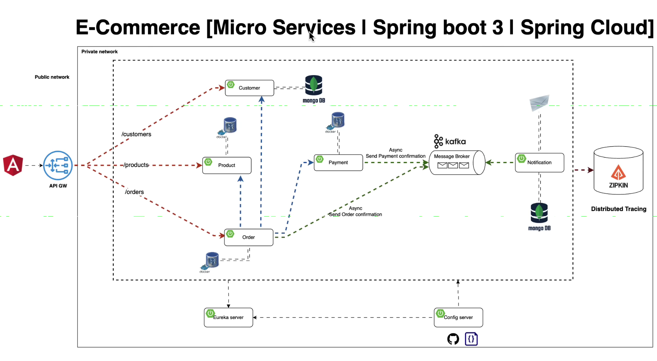

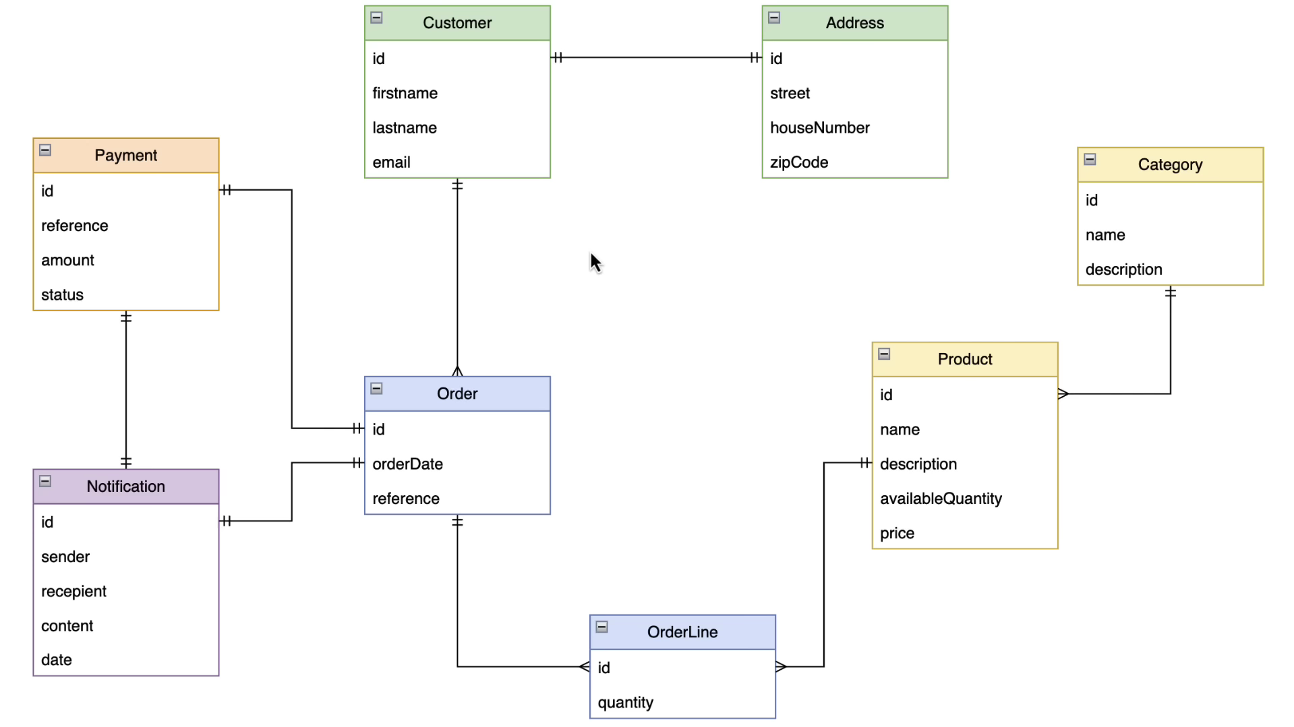
Domain Driven Design(DDD):

